**ISLR 8.4 Conceptual**

**5. Suppose we produce ten bootstrapped samples from a data set containing red and green classes. We then apply a classification tree to each bootstrapped sample and, for a specific value of X, produce 10 estimates of P(Class is Red|X):**

**0.1, 0.15, 0.2, 0.2, 0.55, 0.6, 0.6, 0.65, 0.7, and 0.75.**

**There are two common ways to combine these results together into a single class prediction. One is the majority vote approach discussed in this chapter. The second approach is to classify based on the average probability. In this example, what is the final classification under each of these two approaches?**

p = c(0.1, 0.15, 0.2, 0.2, 0.55, 0.6, 0.6, 0.65, 0.7, 0.75)

Majority approach:

Average approach:

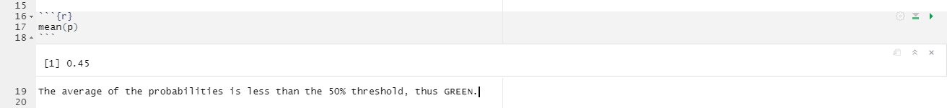

**ISLR 9.7 Conceptual**

**1. This problem involves hyperplanes in two dimensions.**

**(a) Sketch the hyperplane 1 + 3X1 − X2 = 0. Indicate the set of points for which 1 + 3X1 − X2 > 0, as well as the set of points for which 1 + 3X1 − X2 < 0.**

**(b) On the same plot, sketch the hyperplane −2 + X1 + 2X2 = 0. Indicate the set of points for which −2 + X1 + 2X2 > 0, as well as the set of points for which −2 + X1 + 2X2 < 0.**

**2. We have seen that in p = 2 dimensions, a linear decision boundary takes the form β0+β1X1+β2X2 = 0. We now investigate a non-linear decision boundary.**

**(a) Sketch the curve (1 + X1) 2 + (2 − X2) 2 = 4.**

(1+X1)2+(2−X2)2=4(1+X1)2+(2−X2)2=4 is a circle with radius 2 and center (-1, 2).

**(b) On your sketch, indicate the set of points for which (1 + X1) 2 + (2 − X2) 2 > 4, as well as the set of points for which (1 + X1) 2 + (2 − X2) 2 ≤ 4.**

**(c) Suppose that a classifier assigns an observation to the blue class if (1 + X1) 2 + (2 − X2) 2 > 4, and to the red class otherwise. To what class is the observation (0, 0) classified? (−1, 1)? (2, 2)? (3, 8)?**

To restate the boundary, outside the circle is blue, inside and on is red.

**(d) Argue that while the decision boundary in (c) is not linear in terms of X1 and X2, it is linear in terms of X1, X2 1 , X2, and X2 2 .**

The decision boundary is a sum of quadratic terms when expanded.

(1+X1)2+(2−X2)2>4

1+2X1+X21+4−4X2+X22>4

5+2X1−4X2+X21+X22>4